Note: Include this page only when adding / amending / deleting a document. If using this document as a record, this Revision History page can be omitted.

REVISION HISTORY

Revision no | Date | Description of Changes | Reason for Revision | Revised by | Approved by
1 | 06 May 13 | Add revision history page | - Recommendation from Stage 2 audit | RDPlacido
2 | 8 Apr 16 | Added disclaimer when printing the document | For document control | RCGanal | DRFortea
TM-BR-MG- 11 Rev02, 10302015

- Objective
To design new training modules based on client’s or employees’ request.
- Scope
This procedure defines the action and responsibilities of the training unit in responding to requests for new training modules not yet offered by the company. This includes activities from acceptance of training request to the approval of training materials for the new training module.
- Definition of Terms
ManCom | The Management Committee composed of the Execom and all Unit Heads
Execom | The Executive Committee is composed of the President, the Vice-President for Business Development, th Vice-president for Finance, the Sales and Marketing Champion and the Chief Information Officer

- Procedure Details
RESPONSIBLE | ACTIVITY | INTERFACE
Training Head  Execom  Sales /HR | 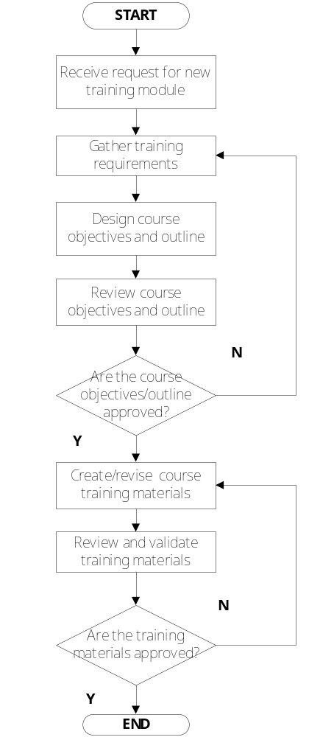 | Sales and HR  Training Requirement Specs  New course Outline  Training materials for new training module

- References
- Guidelines for Classroom Training
- Procedure on Personnel Training

- Quality Records
- Course Outline for new training module
- Training materials for new training module
- Training requirement specs

